B.K. Jewellers

**Function Requirement Specification (FRS)**

**Document for**

**“Sales management” department.**

Document NO: 001

Date: 07-02-2020

Prepared by:

Group 2

* **Revision History**

|  |  |  |  |
| --- | --- | --- | --- |
| **Revision Number** | **Revision Date** | **Summary of changes** | **Author** |
| **1** | 07/02/2020 | Document made. | Ghanshyam gamit |
| **2** | 18/04/2020 | * **Table of content:** Page numbers added. * (**2.1 &2.2 IMAGE**)**:** Indicators added. * **(2.1 &2.2 all elements):** Button state (active) added. | Rudra soni |
| **3** | 30/04/2020 | * **Table of content:** new items added. * **(2.1.2)New Sale:** wireframe added and explained. | Rudra soni |
| **4** |  |  |  |

* **Table of Contents** -

|  |  |  |
| --- | --- | --- |
| Sr.  No. | Content | Page  No. |
| 1. | Introduction |  |
|  | * 1. Objective | 4 |
|  | 1.2 Scope | 4 |
|  |  |  |
| 2. | Functional Description |  |
|  | 2.1 Salesman | 4 |
|  | 2.1.1 Homepage | 4 |
|  | 2.1.2 New sale | 8 |
|  | 2.2 Sales manager | 16 |
|  |  |  |
|  |  |  |
| 3. | System hardware | 20 |
|  |  |  |
| 4. | Security | 20 |
|  |  |  |
| 5. | Regulatory requirement |  |
|  | 5.1 Accurate record generation | 20 |
|  | 5.2 Timeouts | 21 |
|  | 5.3 Operational system checks | 21 |
|  | 5.4 Electronic signature manifestation | 21 |
|  | 5.5 User password controls | 21 |
|  | 5.5.1 Password expiration | 21 |
|  | 5.6 Additional system controls | 22 |
|  | 5.6.1 Event logging | 22 |
|  | 5.6.2 System access | 22 |
|  | 5.6.3 Input checks | 22 |

1. **Introduction**
   1. Objective:

This is the functional requirement specification (FRS now onwards) for “Sales” functionalities used by sales department of **B.K. Jewellers.**

The FRS is details the capabilities and functions that the software must be capable of and reliably perform functionalities.

* 1. Scope:

This document applies to the “Sales department” of software. The document will address the functions of “Sales department” must be able to successfully perform primary business requirements. The focus is on what the “Sales department” must do.

1. **Function description**
   1. Salesman
      1. Homepage

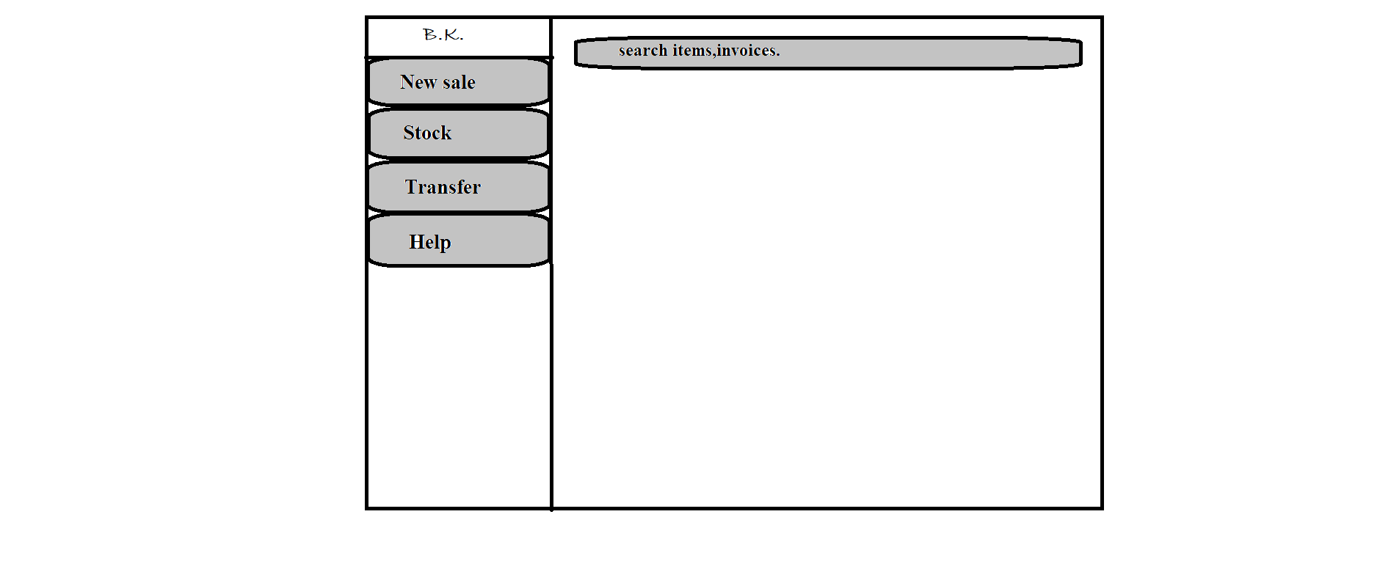

F

C

D

E

B

A

1. Logo

* Type: image
* Use: only for design
* Events: none
* Source: BKlogo.png

1. New sale

* Type: button
* Text on button: New sale
* Background color(Active): gray
* Use: to create a new sale invoice.
* Events:

click:- navigate user to preformatted invoice into editing mode.

Hover:- display information (text) “new invoice.” below mouse arrow.

* Functions:
* Automatic new invoice number generated.
* When button is clicked a preformatted invoice preview will open in editable mode.
* After scanning barcodes full details from database of an item will be displayed in respective fields automatically.
* Automatic GST will be added and final price will appear.
* After clicking submit button placed on below right corner, invoice has been sent to get printed via connected printers.

1. Stock

* Type: button
* Text on button: Stock
* Background color (Active): gray
* Use: used for daily scanning of stock.
* Events:

click:- navigate user to a new window which contains two columns, one is full of available stock list and other is empty which is used for counting.

Hover:- display information (text) “daily stock scanning.” below mouse arrow.

* Functions:
* When clicked user will navigate to a new window which contains two columns side by side, one is full of available stock list and other is empty which is used for counting.
* When a barcode of an item is scanned, it will match the data and transfer that item from right column to right column.
* If any barcode is scanned twice, scanning process will be stopped at that point.
* After completion of scanning user will click submit button placed on bottom right corner.
* When submit button is clicked all data will be stored into database with date and completion time.

1. Transfer

* Type: button
* Text on button: Transfer
* Background color(Active): gray
* Use: to change location of item.
* Events:

click:- navigate user to preformatted location transfer voucher (source: loctransfer.xlsx) into editing mode.

Hover:- display information (text) “location transfer.” below mouse arrow.

* Functions:
* Automatic new voucher number will be generated.
* When button is clicked user will navigate to preformatted location transfer voucher (source: loctransfer.xlsx) into editing mode.
* User will have to add items by scanning barcodes only.
* When a barcode of any item is scanned, the item is shown on right column with its full details submitted on adding to the stock.
* When submit button is clicked a preview of voucher will appear and all scanned items will added to stock of destination location and removed from current location.

1. Help

* Type: button
* Text on button: Help
* Background color(Active): gray
* Use: to acknowledge the user.
* Events:

click:- a help page (source: help.docx)will appear which contains all information of every single step.

Hover:- display information (text) “help.” below mouse arrow.

* Functions:
* When button is clicked help.docx page will appear in full window.

1. Search

* Type: Search bar
* Placeholder:
* Use: search any invoices and items.
* Events:

click:- activate keyboard for input.

* Functions:
* When user click on search bar keyboard will be activated for input.
* When “Enter” button is clicked after any invoice number or item code is entered software will search matching data from database and show all details and last operation done on item in new window.
  + 1. New sale:

d

c

b

i

h

e

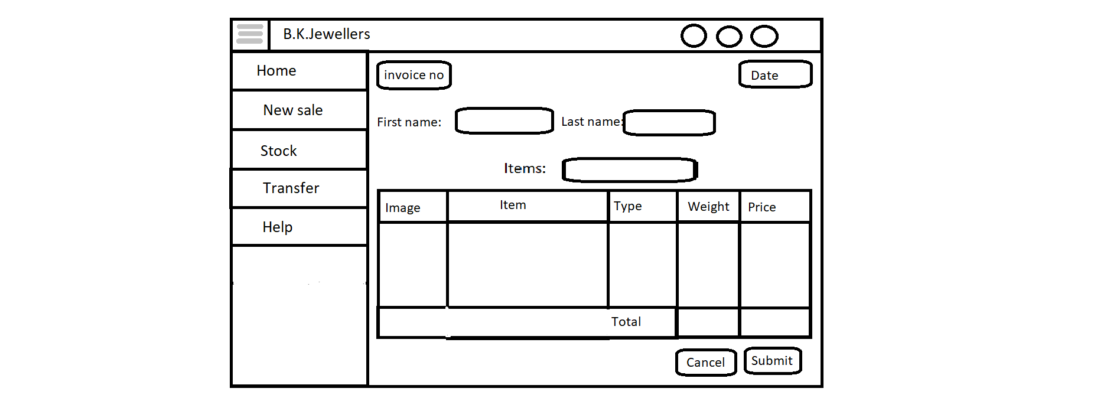

m

l

k

j

g

f

a

o

n

1. Toggler:

* Type: button.
* Text on button: toggle icon(3 strips).
* Use: It is used to toggle side menu.
* Events:

Click:- When user click on button the sidebar menu will be shrink to width of button.

Hover:- When user hover on button cursor changes to pointer.

* Function:
* When user clicks on the button, width of sidebar menu will shrink to the width of button therefore it looks like strip on left side.

1. Search:

* Type: button
* Text on button: search icon.
* Border Shape: circle.
* Use: used to search any invoice by its number.
* Events:

Click:- When user click on button search bar appears.

Hover:- When user hover on button cursor changes to pointer.

* Function:
* When clicked an input field appears at the place of button to search saved invoices.
* If entered invoice number is found, then data will appear in defined format.
* If entered invoice number is not found, an alert message appears with “Invoice not found!!” text.

1. Notification:

* Type: button
* Text on button: notification(bell) icon.
* Border Shape: circle.
* Use: used to view any notification from administration.
* Events:

Click:- When user click on button list of notification appears in small box at bottom of button.

Hover:- When user hover on button cursor changes to pointer.

* Function:
* When clicked a box containing notification appears at bottom of the button.
* If any notification is there, it will appear in list form in box.
* If there is no any notification, box will appear with message of “Nothing to see!” in it with light colour text.

1. User indicator:

* Type: button
* Text on button: user icon.
* Border Shape: circle.
* Use: used to display user which is login to software.
* Events:

Hover:- When user hover on button a tooltip appears at bottom with username which is login to software.

* Function:
* It saves username which is used to log in software and show it when user hovers on it in the form of tooltip.

1. Invoice number indicator:

* Type: input box.
* Information: Invoice number.
* Appearance: Highlighted and like a button with some border.
* Use: to show invoice number.
* Limitations: user can’t give input, user can’t select text.
* Events:

Hover:- When user hover on button cursor changes to pointer.

* Functions:
* Software check the invoice number from previously saved one in database and give one increment in the number and show it as new.
* Process will be repeated every time when user comes on this page for generating invoice.
* If invoice is not submitted, the process of generating new number will goes false and the number will not be saved.

1. Date:

* Type: input box.
* Information: current date.
* Appearance: Highlighted and like a button with some border.
* Use: to show current date.
* Limitation: user can’t give input, user can’t select text.
* Events:

Hover:- When user hover on button cursor changes to pointer.

* Functions:
* Scan current date and copy it in “dd/mm/yyyy” format.
* Process will be repeated every time when user comes on this page for generating invoice.

1. First name:

* Type: text.
* Information: First name.
* Appearance: bold.
* Use: to indicate purpose of input field.
* Events: none.
* Function: none.

1. Input field:

* Type: input field.
* Information: First name as placeholder.
* Appearance: bordered box with shadow.
* Use: to enter first name of client.
* Events:

Click:- When user click on it style changes.

* Function:
* On focus border will be highlighted from left.
* Saves value to server when invoice is submitted.

1. Last name:

* Type: text.
* Information: Last name.
* Appearance: bold.
* Use: to indicate purpose of input field.
* Events: none.
* Function: none.

1. Input field:

* Type: input field.
* Information: Last name as placeholder.
* Appearance: bordered box with shadow.
* Use: to enter last name of client.
* Events:

Click:- When user click on it style changes.

* Function:
* On focus border will be highlighted from left.
* Saves value to server when invoice is submitted.

1. Item:

* Type: text.
* Information: Item.
* Appearance: bold.
* Use: to indicate purpose of input field.
* Events: none.
* Function: none.

1. Input field:

* Type: input field.
* Information: Items as placeholder.
* Appearance: bordered box with shadow.
* Use: to add items for invoice.
* Limitations: input accepted only by barcode scanning.
* Events:

Click:- When user click on it style changes to indicate active state.

* Function:
* On focus border will be highlighted from left.
* When clicked barcode scanner activated for scanning and table for displaying values of items will get inputs from this.

1. Table:

* Type: table.
* Information of headings: Images, Item, Type, Weight and Price.
* Appearance:
* 5 columns and rows(scrollable if items are more except last).
* Headings are bolder and have different background colour.
* Last row containing 3 columns for addition of weight and price.
* Limitations: input accepted only by barcode scanning.
* Use: display scanned items.
* Events: none.
* Function:
* Input from barcode scanned in **input field at (i)**, and find the relative information of that item from database for example: image, weight, etc.
* Display the information in respective columns.
* Addition of all vales of **weight** and **price** done at last row.
* Addition of GST values to **price**.

1. Cancel button:

* Type: button.
* Text on button: Cancel
* Appearance: red bordered with same font colour.
* Use: cancel the current generated invoice.
* Event:

Click:- When user click on it deletion of all work done on current invoice.

Hover:- When user hover on it style get changed.

* Function:
* When user hover on button background colour changes to red and font becomes white.
* When clicked all process goes false and it deletes all work done on current invoice.
* When invoice get cancelled user will navigate to home page.

1. Submit button:

* Type: button.
* Text on button: Submit
* Appearance: green bordered with same font colour.
* Use: submits the current generated invoice.
* Event:

Click:- When user click on it new invoice get registered.

Hover:- When user hover on it style get changed.

* Function:
* When user hover on button background colour changes to green and font becomes white.
* When user click on button all processes become true.
* Scanned items get removed from stock of respective branch.
* User will navigate to new page which shows preview of generated invoice in predefined format for printing invoices
  + 1. Stock
    2. Transfer
    3. Help
  1. Sales manager

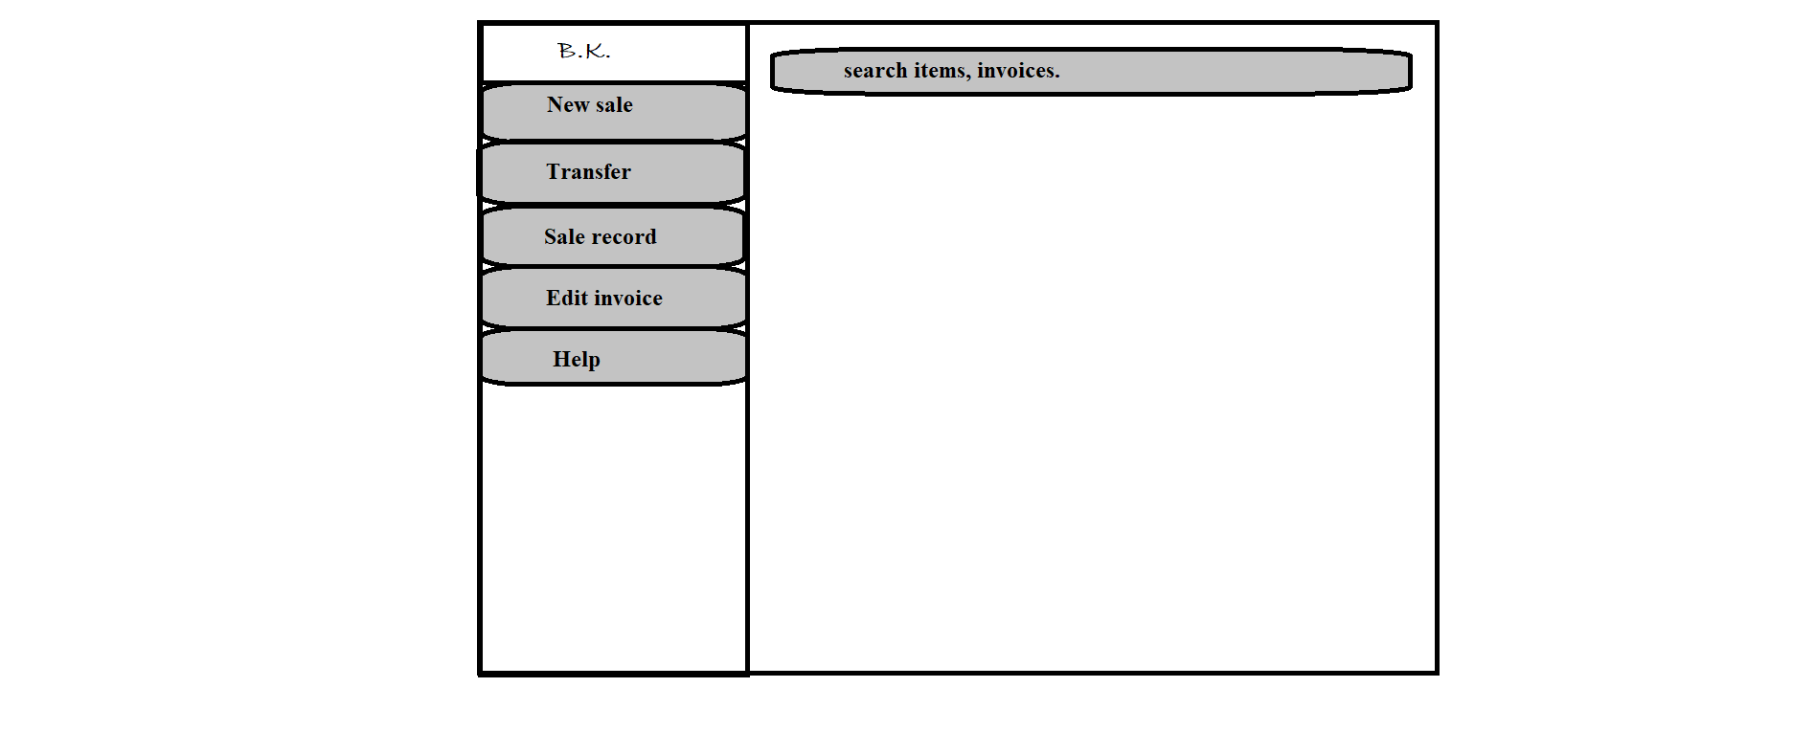

f

e

d

c

b

g

a

1. Logo

* Type: image
* Use: only for design
* Events: none
* Source: BKlogo.png

1. New sale

* Type: button
* Text on button: New sale
* Background color(Active): gray
* Use: to create a new sale invoice.
* Events:

click:- navigate user to preformatted invoice into editing mode.

Hover:- display information (text) “new invoice.” below mouse arrow.

* Functions:
* Automatic new invoice number generated.
* When button is clicked a preformatted invoice preview will open in editable mode.
* After scanning barcodes full details from database of an item will be displayed in respective fields automatically.
* Automatic GST will be added and final price will appear.
* After clicking submit button placed on below right corner, invoice has been sent to get printed via connected printers.

1. Transfer

* Type: button
* Text on button: Transfer
* Background color(Active): gray
* Use: to change location of item.
* Events:

click:- navigate user to preformatted location transfer voucher (source: loctransfer.xlsx) into editing mode.

Hover:- display information (text) “location transfer.” below mouse arrow.

* Functions:
* Automatic new voucher number will be generated.
* When button is clicked user will navigate to preformatted location transfer voucher (source: loctransfer.xlsx) into editing mode.
* User will have to add items by scanning barcodes only.
* When a barcode of any item is scanned, the item is shown on right column with its full details submitted on adding to the stock.
* When submit button is clicked a preview of voucher will appear and all scanned items will added to stock of destination location and removed from current location.

1. Sale record

* Type: button
* Text on button: Sale record
* Background color(Active): gray
* Use: to change location of item.
* Events:

click:- a new window will appear containing list of generated invoices before current date with invoice number and name of customer.

Hover:- display information (text) “sale records.” below mouse arrow.

* Functions:
* When button is pressed, software will collect images of all invoices.
* Excluding those invoices will which are generated on current date.
* The information gathering process will take 5 seconds maximum.
* When the result is ready, it will be displayed in ascending order with respect to generation date (current one should be at top).

1. Edit invoice

* Type: button
* Text on button: Edit invoice
* Background color(Active): gray
* Use: to make changes in submitted invoices.
* Events:

click:- a new window will appear for entering invoice number and after entering invoice number user will have to click on “ok” button placed on bottom-right corner of window.

Hover:- display information (text) “Edit invoices.” below mouse arrow.

* Functions:
* When button is pressed, a new window will appear for entering invoice number.
* After invoice number is entered software will match the number from all invoices submitted in database.
* If match is found, it will be displayed in editing mode else an error massage will pop-us “not found.”.
* If any changes in price, final price will be calculated automatically.

1. Help

* Type: button
* Text on button: Help
* Background color(Active): gray
* Use: to acknowledge the user.
* Events:

click:- a help page (source: help.docx)will appear which contains all information of every single step.

Hover:- display information (text) “help.” below mouse arrow.

* Functions:
* When button is clicked help.docx page will appear in full window.

1. Search

* Type: Search bar
* Placeholder:
* Use: search any invoices and items.
* Events:

click:- activate keyboard for input.

* Functions:
* When user click on search bar keyboard will be activated for input.
* When “Enter” button is clicked after any invoice number or item code is entered software will search matching data from database and show all details and last operation done on item in new window.

1. **System hardware**

The software can run on the minimum standard PC workstation or laptop configuration by **B.K. Jewellers.** This part can be accessible by all PC present in workgroup of organization for “Sales”.

This part of the software does not affect the organization LAN.

1. **Security description**

The sales part is only accessible through the software provided by “BlackSky Systems.” This software or any part of the software does not open from outside the configured environment of **B.K. Jewellers.**

1. **Regulatory requirements**
   1. Accurate record generation:

The functionality meets the following requirements:

* The ability to generate accurate and complete copies of record in both human readable and electronic form is suitable for inspection & review by the agency.
* Users are able to select search queries.
* Users are able to export data through MS Excel sheet.
  1. Timeouts:

The software for “Sales department” will not automatically time-out, it is supposed to run after login till the user logout from the system.

* 1. Operational system checks:

The “Sales department” software uses operational system checks for permitted sequencing of steps and events.

* 1. Electronic signature manifestation:

The software has secure data in system through electronic signatures. Data secured with an electronic signature cannot be edited or deleted unless the signature is removed.

* 1. User password controls:

This software does not allow user to change their passwords. Only the administration has this authority.

5.5.1 Password expiration:

Once the password is created it never expires unless user requested to change it.

* 1. Additional system controls:

5.6.1 Event logging:

It includes system login and logout, as well as attempts failures.

5.6.2 System access:

Access to software must be controlled by user access to the LAN controlled by system identification and password.

5.6.3 Input checks:

When appropriate entries may programmatically checked before being accepted by software.(for example, No negative values accepted for item price.)